1. dk
2. Let’s create interface:  
   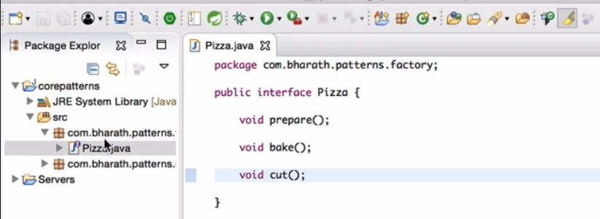
3. Let’s implement Pizza Interface.  
   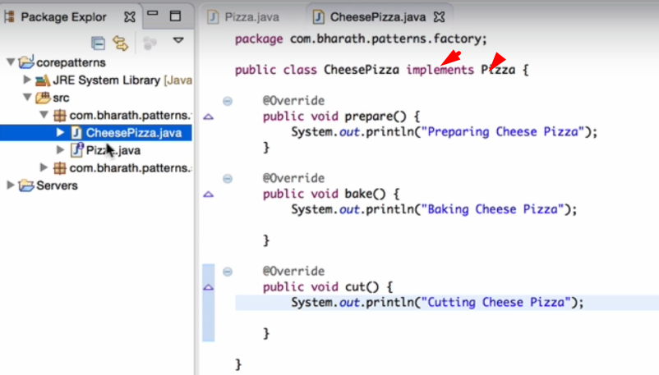
4. Let’s create one more implementation.  
   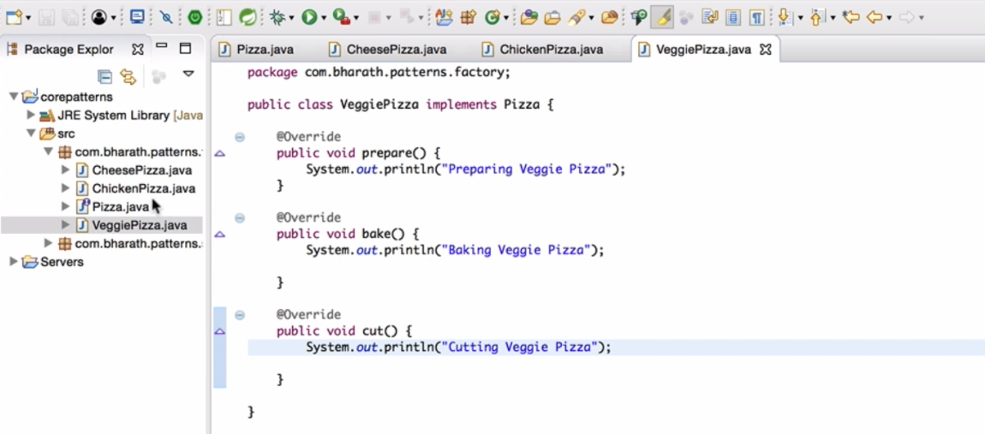
5. 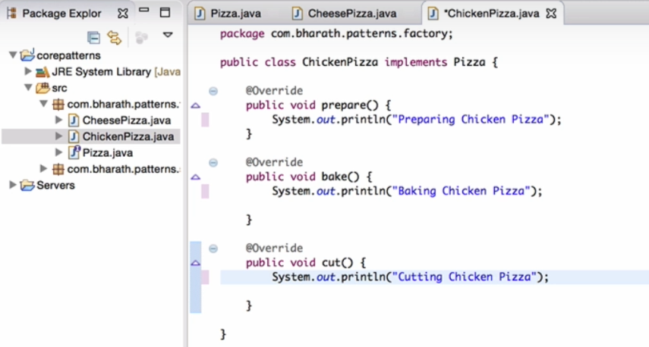
6. We created 3 implementations for Pizza interface.
7. 